
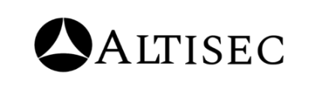

TATA TECHNOLOGIES
SOC REPORT JUNE
WEEK 04(01ST TO 07TH JUNE) 2026
DATE: 08TH JUNE 2026

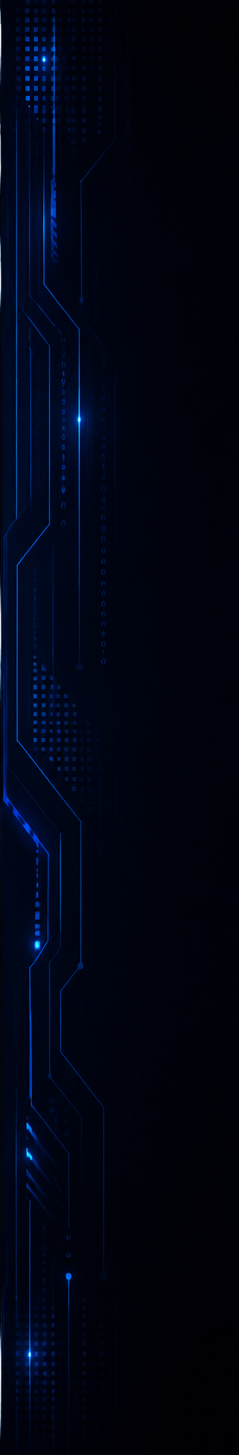

FOREWORD
This Weekly Executive summary report has been produced by ALTISEC TECHNOLOGIES PVT. LTD. Security Operations (SOC) team covering TATA TECHNOLOGIES. critical infrastructure and information processing assets under the purview of 24*7- daily real time SOC operations.

TATA TECHNOLOGIES
SOC SERVICES:

Objectives & Goals:
Our consultants are highly focused towards eliminating the noise (unwanted traffic, Incidents/Cases) by identifying and prioritizing real actionable threats and help TATA TECHNOLOGIES to take necessary preventive actions for the reported tickets that may put the business at risk.

Security Operations:
- Our Security Operations Center (SOC) activities and reports are tracked, reviewed, and communicated on a periodic basis to capture SOC performance and enhancements over time.
- Top 10 Security Risks, Daily Incidents & cases Tickets are all logged, tracked.

Incidents & cases Reporting:
- Our incidents & cases reporting strategies with root cause analysis helps TATA TECHNOLOGIES management to document significant security risks to information processing assets.
- The incidents & cases reports clearly communicate incidents & cases type, incident risk & cases risk and severity, and specific event details covering a detailed technical analysis of the incidents & cases analyzed by our consultants.


RISK CALCULATION
The risk rating section describes the potential impact if the identified security Incidents/Cases is exploited by a threat source, or the severity of the security Incidents/Case/event is generated. The risk rating is calculated by considering the “Ease of exploitation” and the “Potential Impact” on application, servers, endpoints, and Critical Network Devices.

Rating | Description
Critical | The security risk/Incidents/Case/event is Critical as either it is considerably easy to exploit the observed incidents & cases, or the gain/impact is Critical. This Incidents/Case should be fixed on an urgent basis. Any security Incidents/Case generated with this severity needs to be treated immediately. Any suspicious but potential attack will also be considered as Critical severity.
High | The security risk/Incidents/Case/event is High as the ease of exploitation of the observed incidents & cases is Moderate, or the attack severity and the overall resulting impact is considerably Moderate.
Medium | The security risk/Incidents/Case/event is Medium as the ease of exploitation of observed incidents & cases and its exposure is Medium. Furthermore, events generated under medium severity are not having any immediate impact on the organization and its data.
Low | The security risk/Incidents/Case/event is Low as the ease of exploitation of observed incidents & cases and its exposure is Low. Furthermore, events generated under Low severity are not having any immediate impact on the organization and its data.

To graphically showcase the health of an asset, the following health icons

will be used as the case arises.

- Indicates that the assets have exceeded the acceptable operational threshold in that performance category and needs to be addressed immediately. Each of the critical health areas are backed up by a recommendation in the recommendations section.

- Indicates that the assets, though not yet in the critical area, but it is likely to exceed the threshold if left unattended.

- Indicates that the assets performance is acceptable in that performance category.

- Indicates that the assets performance is acceptable in that performance category, and it shows the informational or low severity.

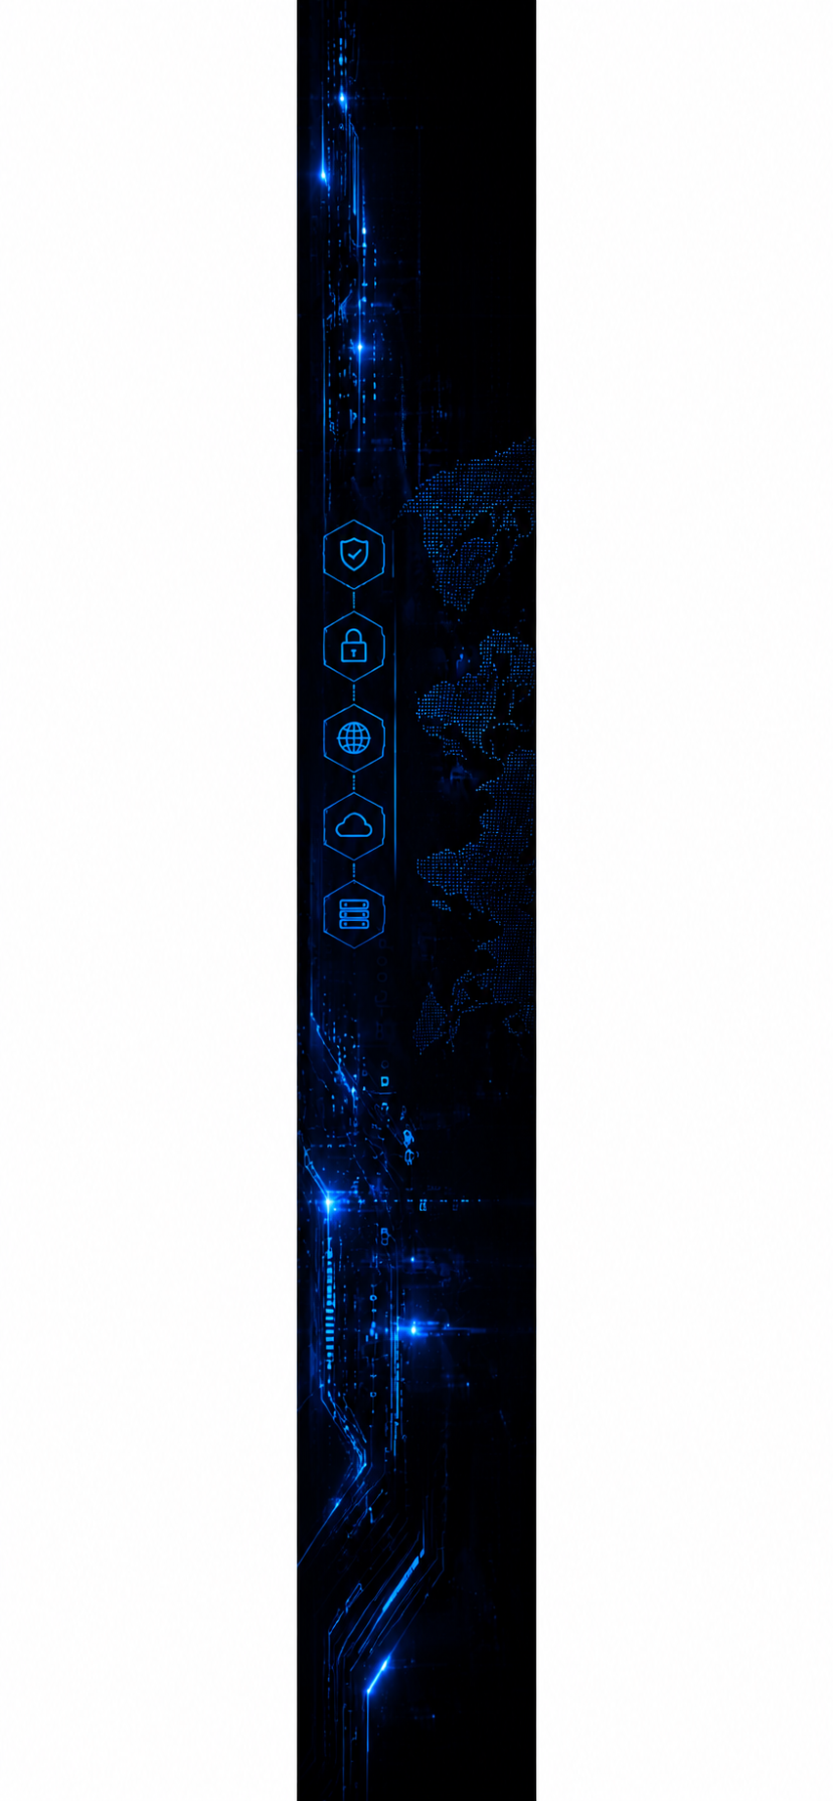

TABLE OF CONTENTS

FOREWORD 2
RISK CALCULATION 3
TABLE OF CONTENTS 4
DOCUMENT PROPERTY 5
SOC ENGAGEMENT TEAM 5
CONFIDENTIALITY CLAUSE 6
OVERVIEW OF INCIDENTS & CASESS 7
GOVERNANCE TEAM MATRIX 15

DOCUMENT PROPERTY

Content | TATA TECHNOLOGIES | Security Operations Services Weekly Report [JUNE 2026 (Week – 01)]
Classification | CONFIDENTIAL
Client | TATA TECHNOLOGIES
Contact | Name - XYZ  mail - xyz@Tata Technologies.com  contact – XYZ
Report Status | Final

SOC ENGAGEMENT TEAM

Analysts’ Names | Roles | Email IDs
Saachi Joshi | Governance | saachi.j@alticyber.com
Shaktiprasad Anami | SOC Manager | shaktiprasad.a@alticyber.com



CONFIDENTIALITY CLAUSE

- No part of this publication may be reproduced or translated into any language in any form by any means without the written permission of ALTISEC TECHNOLOGIES PVT. LTD.

- The security tickets/events denoted in this report can be shared or used by TATA TECHNOLOGIES authorized personnel for their internal usage or to meet any compliance requirement.

- While every precaution has been taken in the preparation of this document, of ALTISEC TECHNOLOGIES PVT. LTD. assumes no responsibility for errors, omissions, or for damages resulting from the use of the information herein.

- This document provides detailed information about security operations services offered to TATA TECHNOLOGIES and related Information Technology environment and is therefore considered CONFIDENTIAL. It also contains detailed information about some of ALTISEC TECHNOLOGIES PVT. LTD methodologies. It contains customer information, resource’s details, and relevant corporate information. Appropriate discretion is advised when sharing this information with third parties.

- Products or corporate names used in the report are trademarks or registered trademarks of respective companies and are used only for a better explanation and to the owner’s benefit, without intent to infringe.

OVERVIEW OF INCIDENTS & CASES
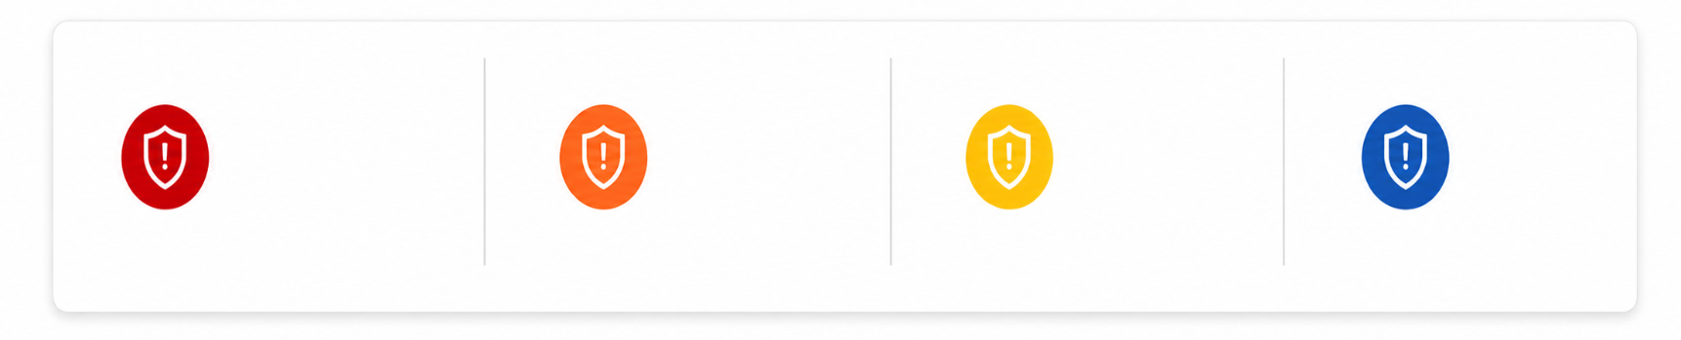
Following is the overview of total incidents & cases based on severity for the reporting period 01ST TO 07TH June 2026.
01

02

03

00

HIGH
CRITICAL
MEDIUM
MEDIUM

LOW
MEDIUM

1. INCIDENTS/CASES BY STATUS
TOTAL INCIDENTS/CASES
06
- OPEN
00 (00%)
- CLOSED
06 (100%)
It shows the information about
the status of all the Incidents/Cases tickets
generated in last 7 days. Which
shows the Incidents/Cases which shows
the Incidents/Cases which are Open and
Closed after the customer’s
acknowledgement by the soc team.

Severity | Cases | New | In Progress | Resolved
Critical
High
Medium
Low
Total

2. OPEN CASE DETAILS
Case Name | Severity | Status | Team/Ownership | Remark

3. SEVERITY WISE OVERALL INCIDENTS/CASE COUNT
Following constitutes the
segregation of Incidents/Case ticket
communicated by SOC team
to TATA TECHNOLOGIES. based
Upon the severity and associated
count.

4. CLOSED SEVERITY WISE OVERALL INCIDENTS/CASE COUNT


Following constitutes the segregation of true positive Incidents/Case ticket communicated by SOC team based upon the severity and associated count.
CLOSED SEVERITY WISE OVERALL INCIDENTS/CASE COUNT

HIGHLIGHT – Medium severity Incidents/Cases were observed majority in the reporting period and all the Incidents/Cases were closed.

5. INCIDENTS/CASES CREATED TREND


Following section depicts the daily Incidents/Case ticket trend for the last 7 days (01st to 07th June 2026). This includes multiple Incidents/Cases which are stitched and scanning related Incidents/Cases.
INCIDENTS/CASE TREND

HIGHLIGHT – 01st and 03rd June had the highest Incidents/Cases.

6. INCIDENTS/CASES SENT BASED ON ALERT NAMES.

This section depicts information about Incidents/Cases triggered of various Incidents/Case names.
INCIDENTS/CASES SENT BASED ON INCIDENTS/CASE NAME

7. MITRE ATT&CK TACTICS

This section depicts MITRE ATT&CK tactics in correspondence with TOP Incidents/Case tickets sent by the SOC team.
INCIDENTS/CASE COUNT BASED ON MITRE TACTICS

8. MITRE ATT&CK TECHNIQUES

This section depicts MITRE ATT&CK techniques in correspondence with TOP Incidents/Case tickets sent by the SOC team.
INCIDENTS/CASE COUNT BASED ON MITRE TECHNIQUES
9. INCIDENTS/CASE CATEGORY

This section provides information about the category of all Incidents/Case tickets generated in the last 7 days.
INCIDENTS/CASE COUNT BASED ON CATEGORY

HIGHLIGHT – Vulnerability tactic accounts for highest number of total Incidents/Cases.


WORKSTATION


LINUX

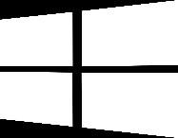
WINDOWS

10. INCIDENTS/CASES BASED ON ASSET TYPE

This section depicts information about TOP Incidents/Case tickets generated on different endpoint types i.e. Servers and Workstations.
INCIDENTS/CASE BASED ON ASSET TYPE
🔵Server
🟠Workstation

HIGHLIGHT – Workstation & Server had the same number of Incidents/Cases.

11. INCIDENTS/CASES TRIGGERED FROM USERNAMES


The graph below depicts the statistics about TOP user due to whom most Incidents/Cases are triggered from 01st to 07th June 2026.
INCIDENTS/CASE TRIGGERED FROM USERNAMES

12. INCIDENTS/CASES TRIGGERED FROM HOSTNAME

The graph below depicts the statistics about TOP host due to whom most true positive Incidents/Cases are triggered from 01st to 07th June 2026.
INCIDENTS/CASE COUNT BASED ON HOSTNAME

13. SLA COMPLIANCE
The SLA adherence for this week's four severity levels—critical, high, medium, and low—is displayed in this section.
RESPONSE

🔵complaint
🔴non-complaint

14. MTTR RESPONSE
The SOC Team maintained SLA-aligned MTTR response by prioritizing Incidents/Cases based on severity for the true positive Incidents/Cases from 01st to 07th June 2026.
RESPONSE

\\

15. MTTR RESOLUTION
The SOC Team maintained SLA-aligned MTTR resolution by prioritizing Incidents/Cases based on severity for the true positive Incidents/Cases from 01st to 07th June 2026
RESOLUTION

16. MTTD
The SOC Team maintained SLA-aligned MTTD by prioritizing Incidents/Cases based on severity for the true positive Incidents/Cases from 01st to 07th June 2026
MTTD

17. MTTA
The SOC Team maintained SLA-aligned MTTA by prioritizing Incidents/Cases based on severity for the true positive Incidents/Cases from 01st to 07th June 2026
MTTA

18. TOP 3 RULES TRIGGERED
RULE NAME | SEVERITY | COUNT
TOP 3 DEVICES BY INGESTION:
(Helps identify noisy /log-heavy sources)

TOTAL DAILY INGESTION
(EVENTS/GB)

217.56GB
DEVICE NAME | INGESTIONS GB

19. PLAYBOOK DETAILS
USE CASE NAME | STATUS | REMARK | OWNERSHIP | ETA

20. NOISY CORELATION RULE DETAILS
USE CASE NAME | FALSE POSITIVE | TRUE POSITIVE | REMARK & OWNERSHIP | ETA

21. BLINDSPOT
xyz | XYZ | XYZ | ETA

GOVERNANCE TEAM MATRIX
As a part of team re-structuring, we have formed a governance layer that will oversee operations. In-case of any queries, please contact the team members (Governance Layer) from the table below.
